This folder “Matlab codes 18042025” contains Matlab files used in the experiments for the paper “Adaptive Remainder Modulo $m$ Data Hiding” by Alexander Chefranov and Gurcu Oz
The experiments seven steps are as follows:

Step 1 Get Stego Images
Stego images are obtained by an embedding algorithm. For this purpose, Make_stegos_30092023.m file is invoked asking for a method name from the drop down menu appearing in a separate window. To synchronize input from the menu and code running, before starting the code, place breakpoint at the statement in line 64 “if method==2” (Fig. 1):
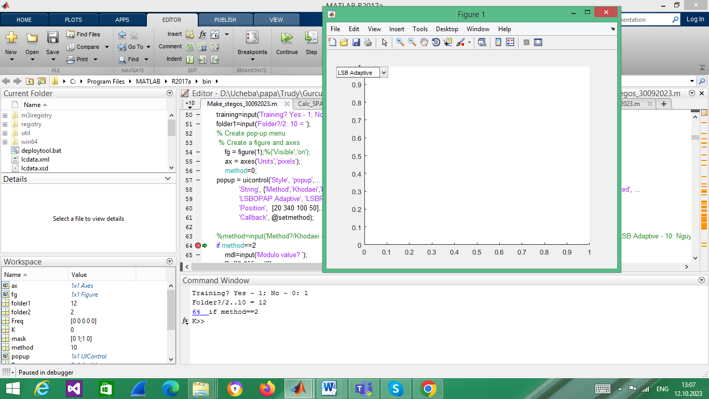
Fig. 1. Control stops at line 64 waiting for the choice of a method (LSB Adaptive is chosen). For “Training?” question, answer 1 always.
Stego images are obtained from the cover images of UCID v2 database 886 color 384x512-sized images we have found in Internet. These color images we use to get 3*886=2568 gray-scale images obtained from their R, G, and B channels and named respectively as 1ucid#.tiff, 2ucid#.tif, and 3ucid#.tif, where # ranges from 00001 to 00886 (Fig. 2):
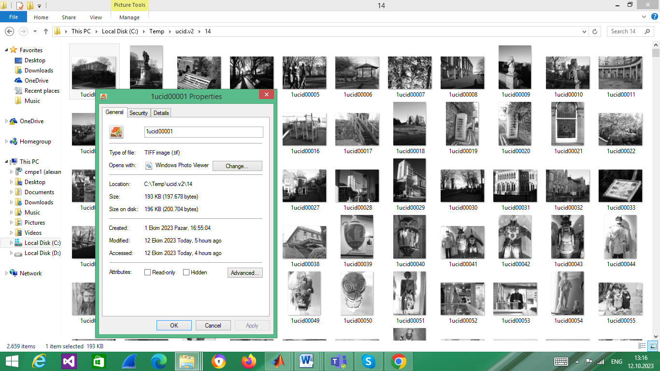
Fig. 2. Grayscale files derived from UCID v2 color 384x512 files
It is supposed that UCID v2 color files are located in the directory c:\Temp\ucidv2. The code reads them one by one, gets three grayscale files, embeds message in each of them and saves resulting stegoimages in the subdirectory with a numerical name, such as “12” used in Fig. 1. The numerical value, NV, of the output directory name defines the payload size used for embedding as size=(NV-2)*chunk, where chunk=2^14 bits. Thus, directory ‘2’ contains images with zero payload (cover images), and directory ‘12’ contains stegoimages with payload=10*2^14 bits, hence, ER=payload/M/N=10*2^14/384/512=5*2^15/(3*2^16)=5/6=0.833 bpp.

Step 2 Get SPAM Features
Once stegoimages are obtained, their 686 SPAM features are calculated using Calc_SPAM_21092018.m code. This code asks for the mode (answer 1), and for the folder to be used (answer folder number you need, as 12 in our case, Fig. 3):
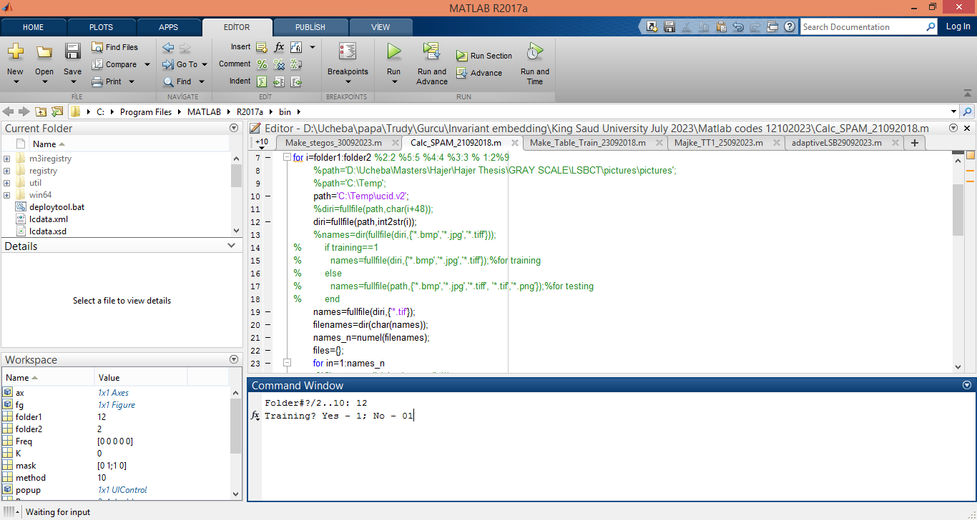
Fig. 3. Invocation of SPAM features calculation for the folder ‘12’
Result will be a file in the specified folder named “features1TR.dat” (Fig. 4):
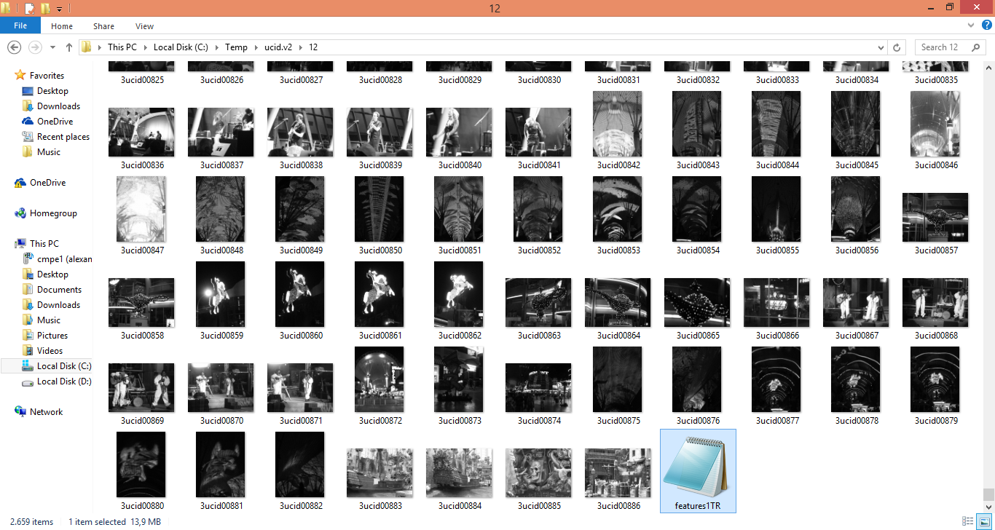
Fig. 4. File features1TR.dat obtained by Calc_SPAM_21092018.m in the folder ‘12’.

Step 3 Prepare a Table TT with the Features of Cover and Stego Images
Table TT of 686 SPAM features for the cover images )from directory 2) and for the stego images (in the case of Fig. 5, from directory 10) is created:
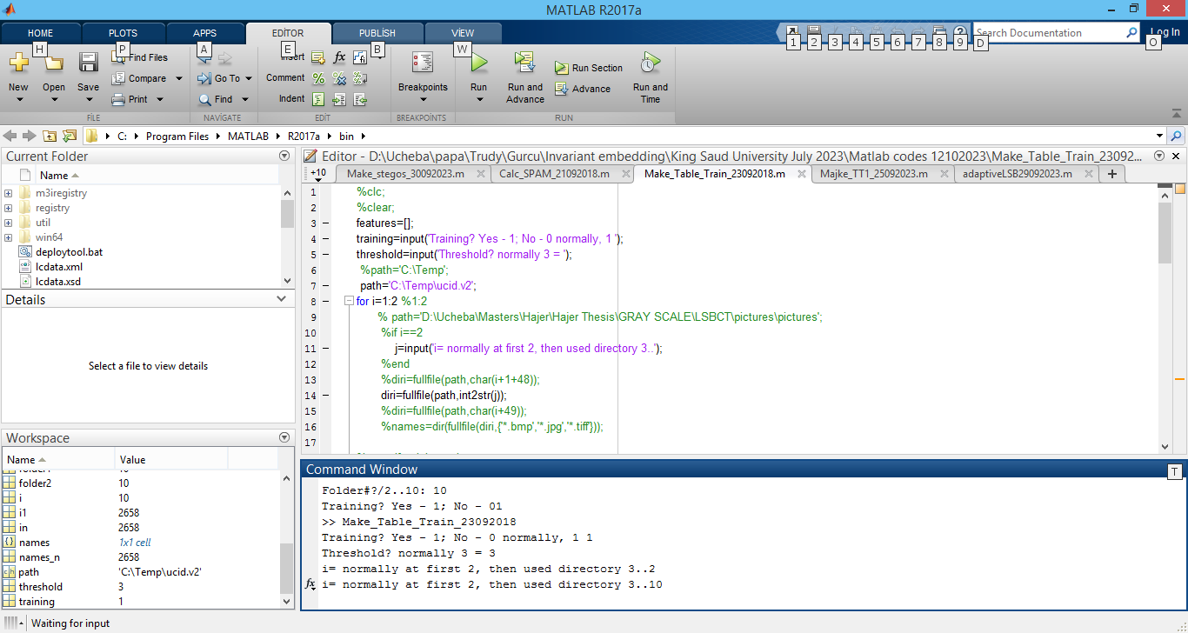
Fig. 5. Creation of the table TT with 686 SPAM features for 2568 cover (its first half) and 2568 stego images (its second half) by Make_Table_Train_23092018.m.
In the dialog in Fig. 5, always answer 1 for “Training?”, answer 3 for “Threshold?”, and ‘i=’, at first, answer 2 (directory with cover image features), and then answer ‘i=’ by your directory number with the stego images features (10 in Fig. 5).

Step 4 Prepare Training TT1 and Testing TT2 Tables
Create two tables, TT1 (for training) and TT2 (for testing) from TT specifying the number of images in the training table (Fig. 6) using the code from Majke_TT1_25092023.m:
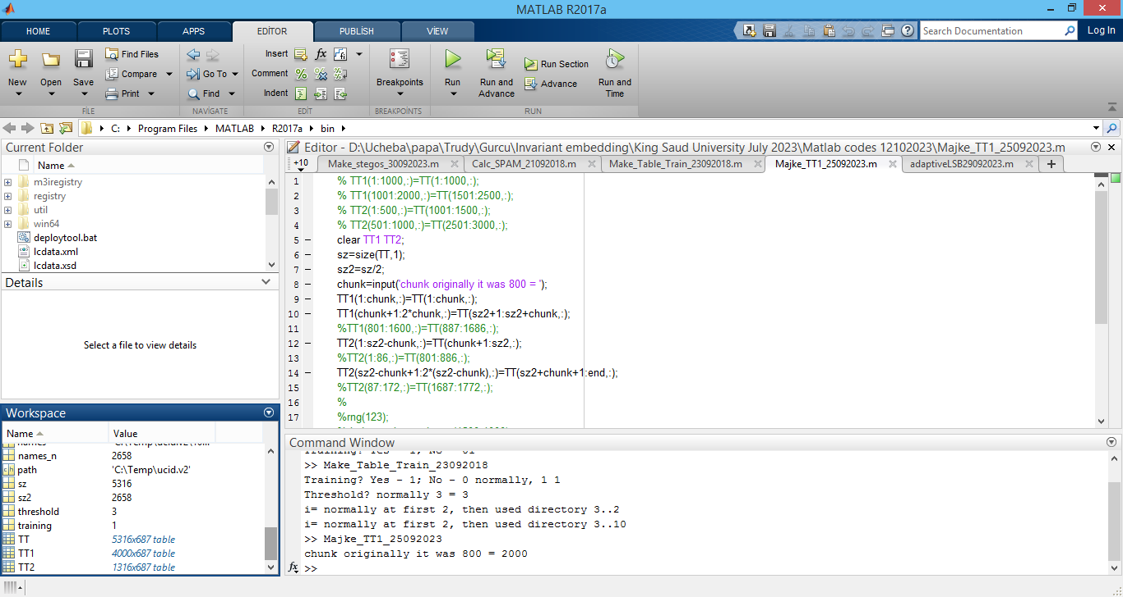
Fig. 6. Creation of TT1 and TT2 from TT using Majke_TT1_25092023 with 2000 image features in TT1 for training and 658 image features for testing. The number of the rows in the tables is twice the number of images (cover and respective stego images).

Step 5 Train Classifiers
Use Matlab Classification Learner (CL) app to train classification models. Fig. 7 shows Classification Learner after invocation:
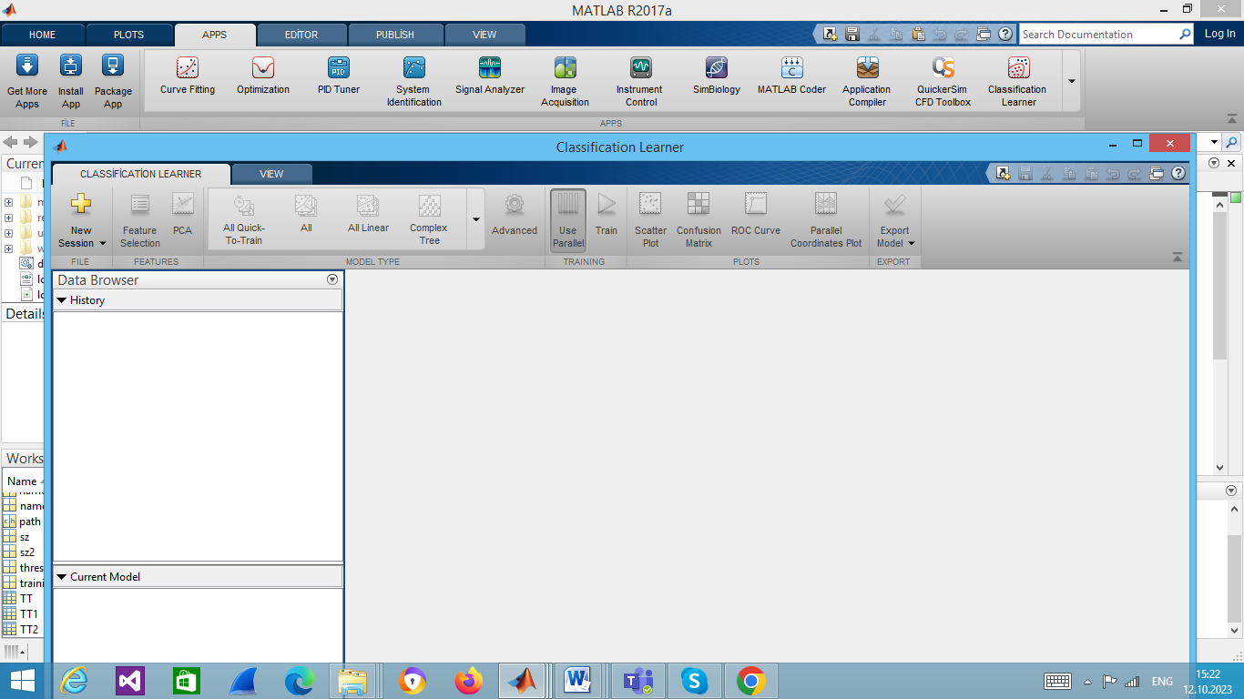
Fig. 7. CL after invocation
It is necessary starting a new session (Fig. 8):
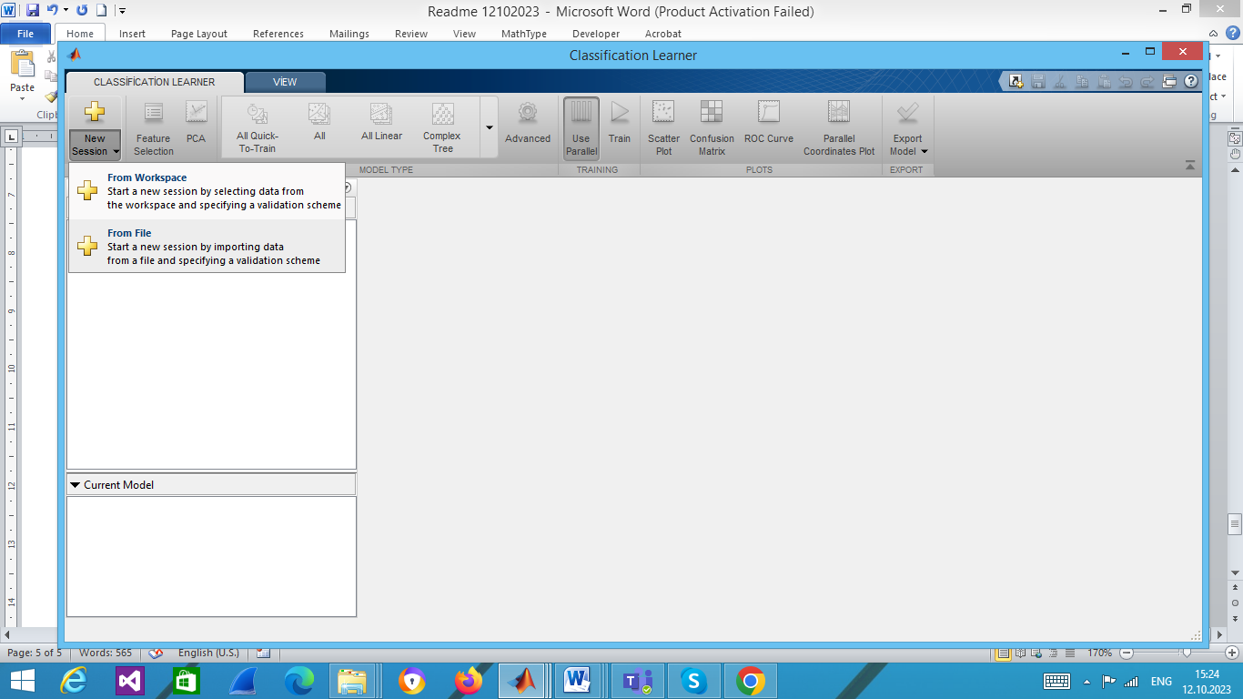
Fig. 8. Creation of a new session by “From Workspace” choosing
In Step 1 of the CL, select TT1, then turn “features687” to “Response” in Step 2, and click “Start Session” in Step 3 (Fig. 9):
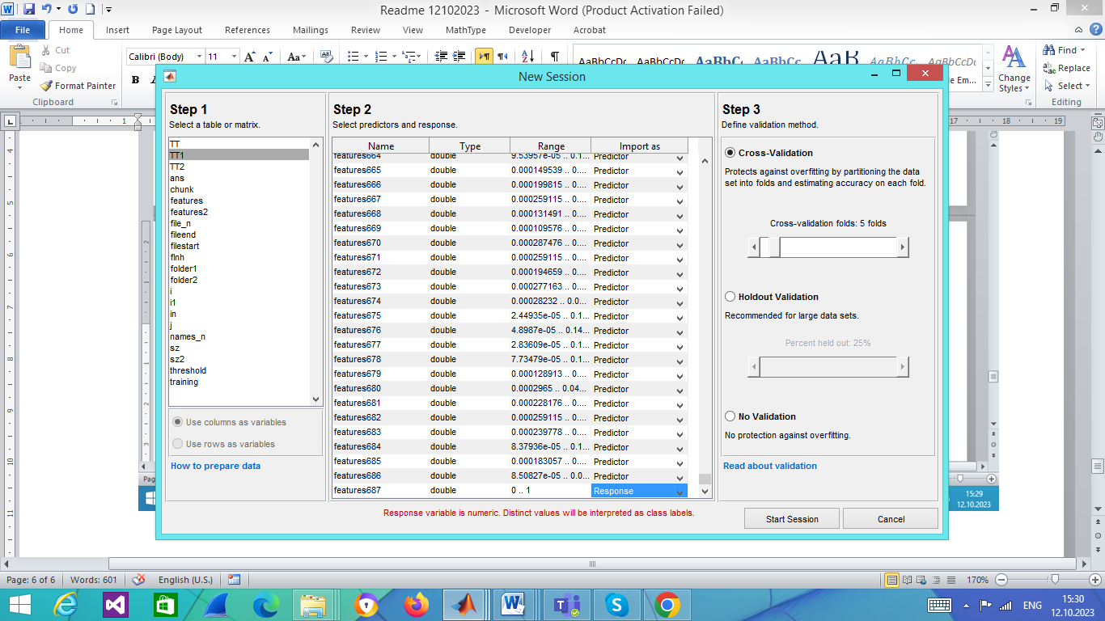
Fig. 9. Select TT1, assign “Response” to “features687”, and click “Start Session”
When session started, select necessary classifier (or group of classifiers) and click green rectangle to start training (Fig. 10):
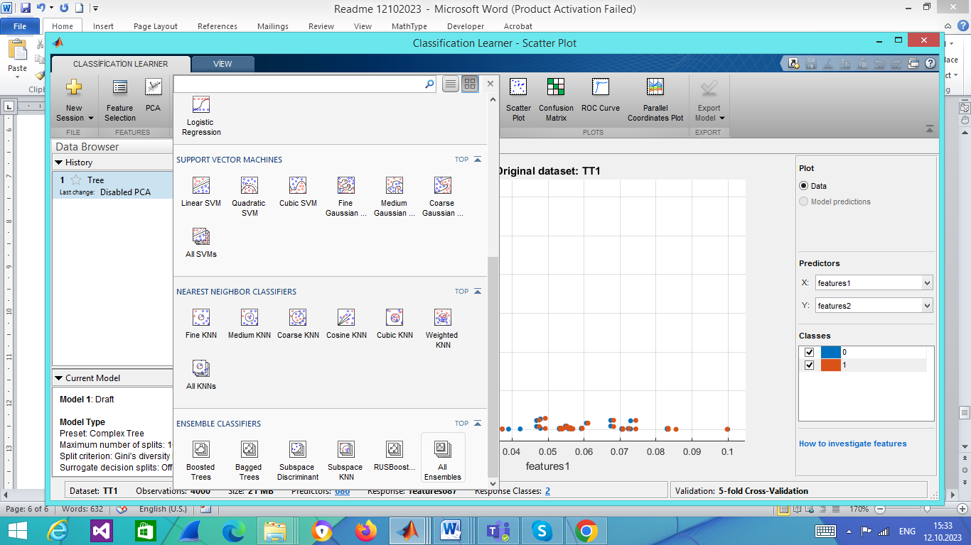
Fig. 10. “All Ensembles” group of classifiers is to be selected
Fig. 11 shows the state after “All Ensembles” group is selected:
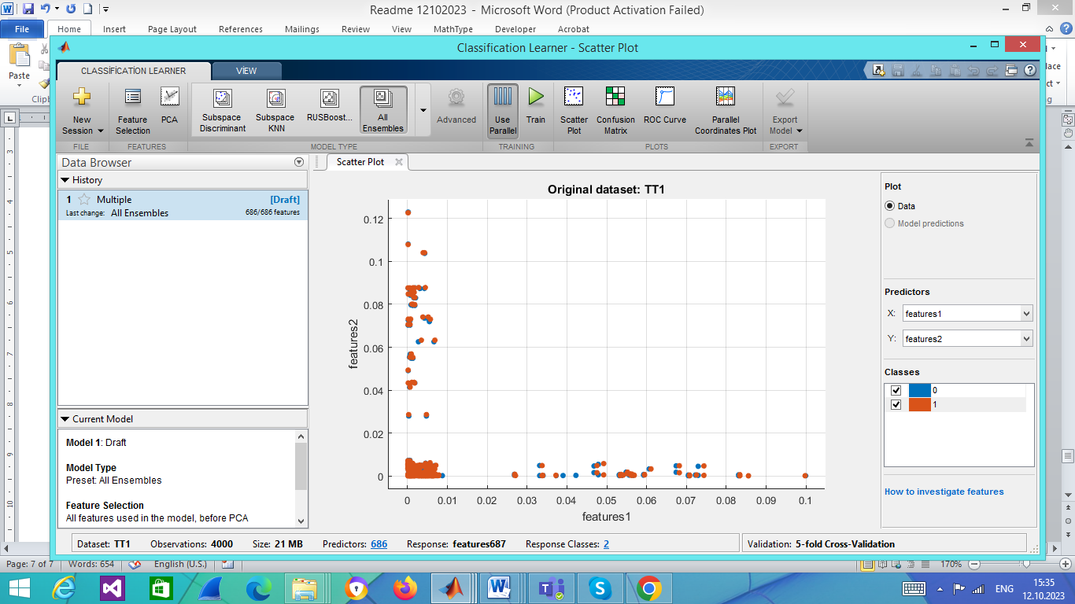
Fig. 11. “All Ensembles” group is selected
Fig. 12 shows start of training after clicking the green triangle:
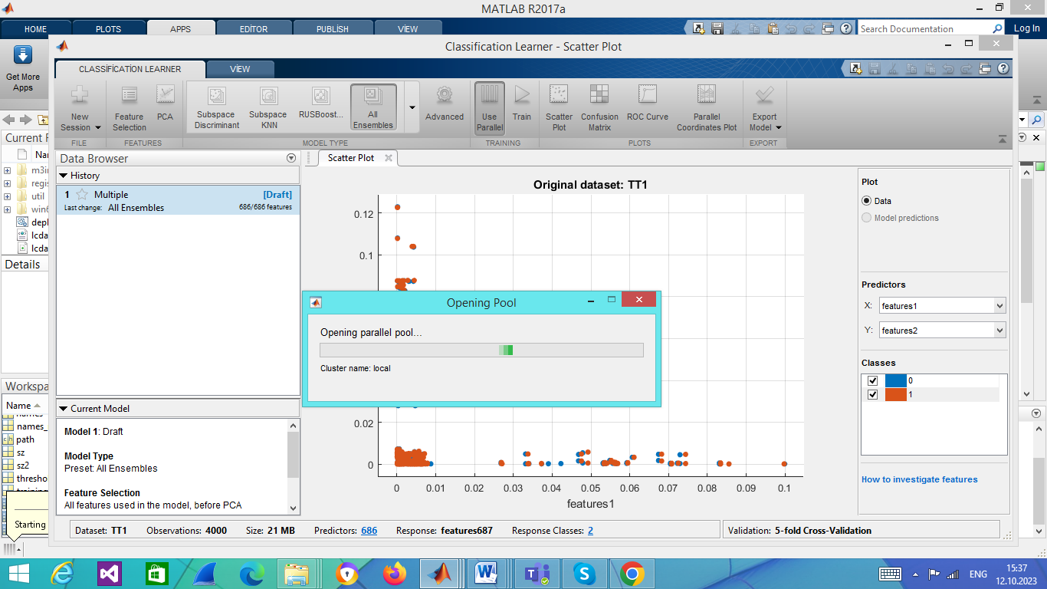
Fig. 12. Preparing a pool of parallel processes for training “All Ensembles”
Fig. 13 shows the state when “All Ensembles” group of classifiers is already trained, and the next group of KNN classifiers are being trained. The current champion Ensenble Boosted Trees with the highest accuracy 80.8% is indicated by a frame:
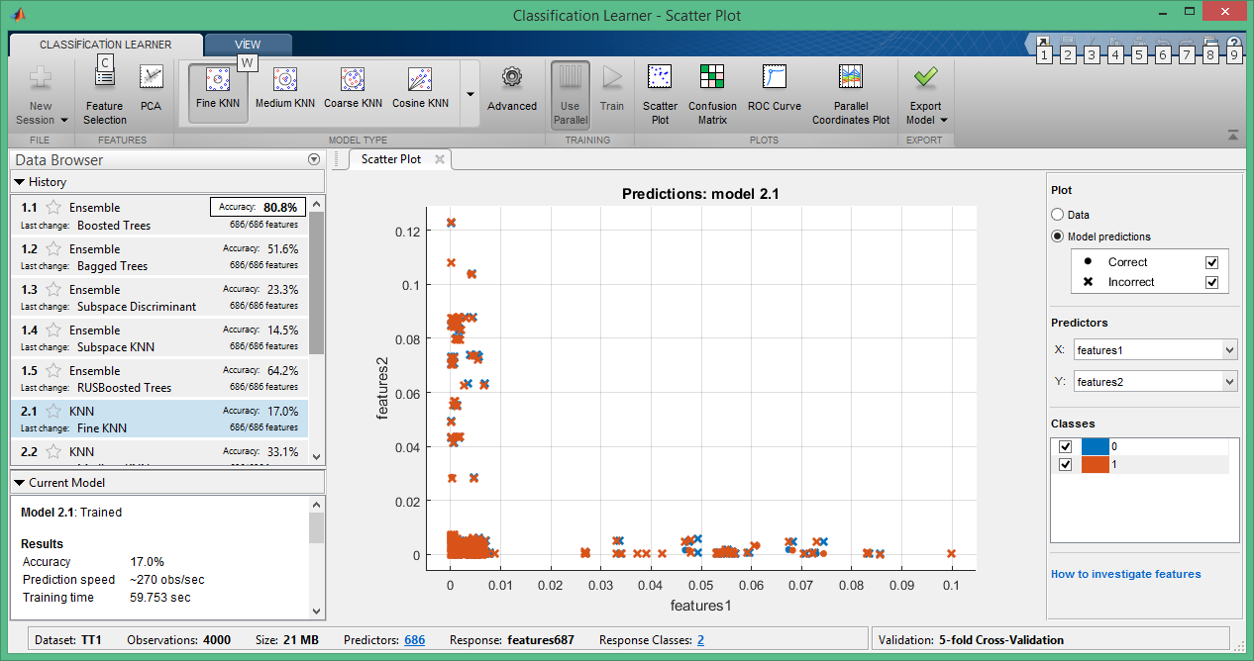
Fig. 13. “All Ensembles” group is already trained, KNN classifiers are still in the progress. Ensemble Boosted Trees is the current champion with 80.8% detection accuracy.

Step 6 Export Trained Model
Once the models are trained, the champion model is selected, and exported to Matlab workspace using the button “Export Model” as shown in Fig. 14:
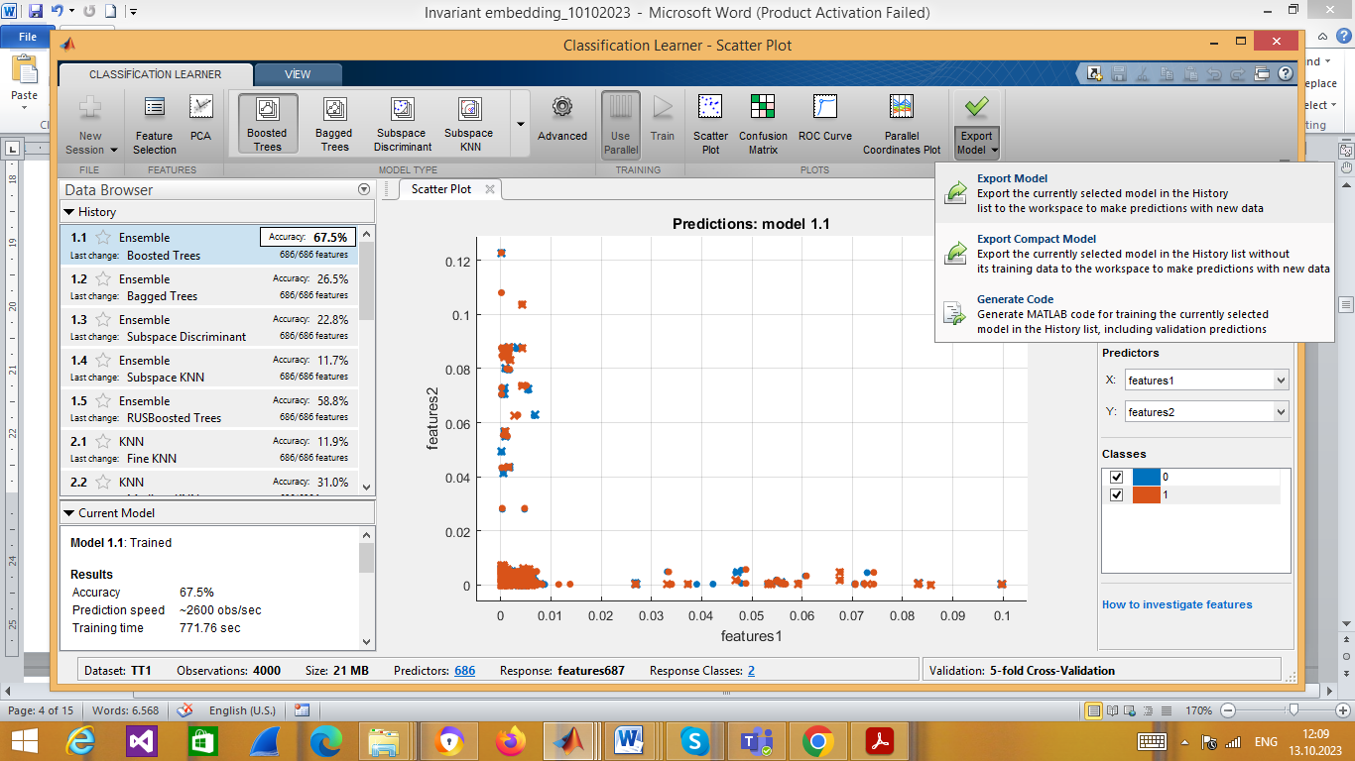
Fig. 14. The champion Ensemble Boosted tree model is to be exported
Export is made defining the name of the model (see Fig. 15):
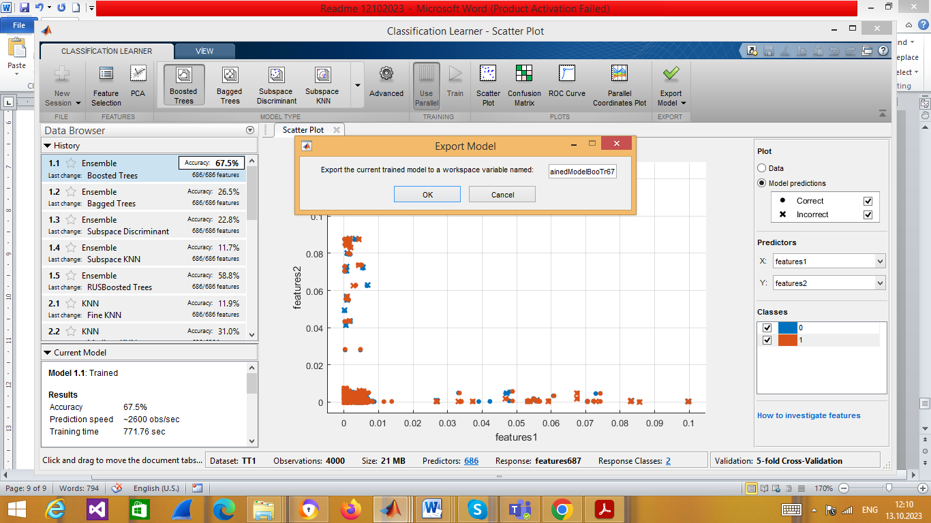
Fig. 15. The exported model name is defined as trainedModelBooTr675
Once exported, respective notification appears in Matlab (Fig. 16):
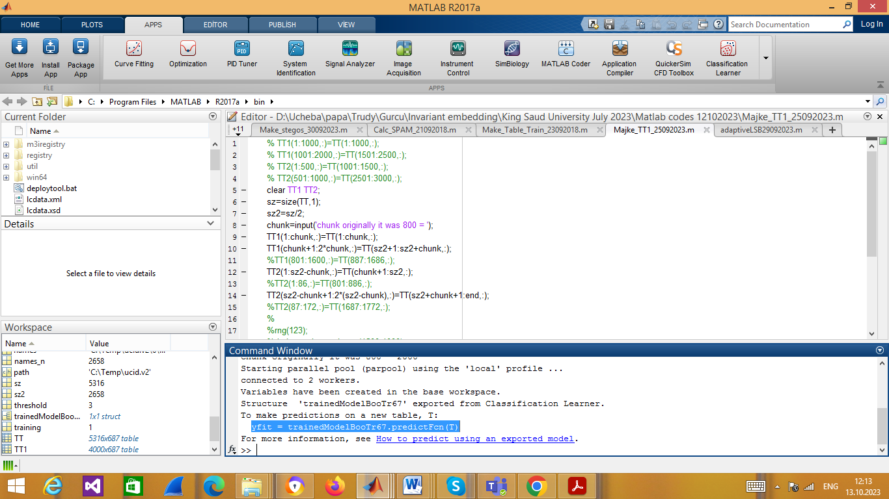
Fig. 16. Automatically generated notification about a trained model exporting and how it can be used

Step 7 Test Images Using TT2
To test images, copy the prompt from the export notification, substitute T by TT2 and launch (Fig. 17):
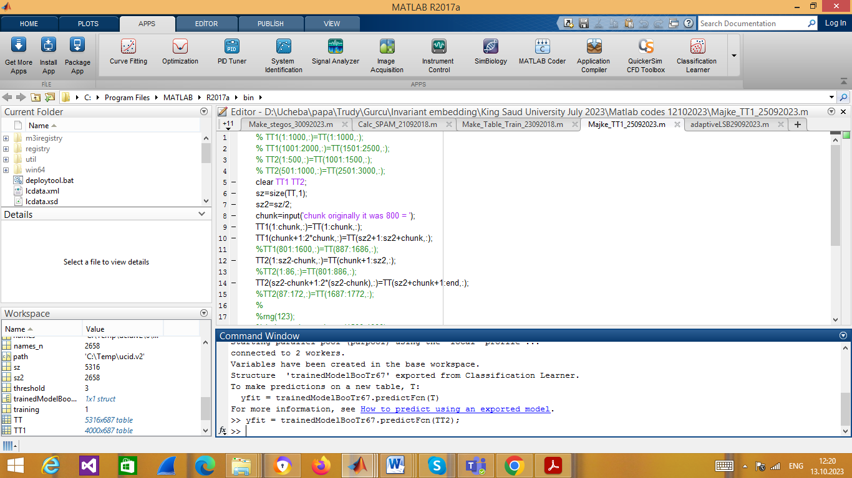
Fig. 17. Testing of images using TT2. Results of classification are presented in yfit
Results of classification are presented in yfit.

Step 7 Get DE, FP and FN from yfit
To get detection error, DE, false positive (FP) number, and false negative (FN) number, use de_calc_28092023.m code (Fig. 18):
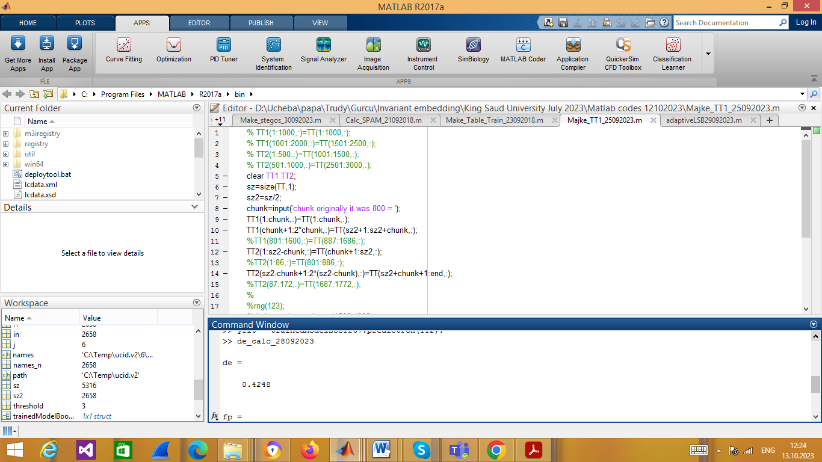
Fig. 18. Getting DE=42.48%, FP and FN (not visible)

